**Gurukrupa College of Education & Research, Kalyan**

***Feedback Analysis of B.Ed. Students (A.Y. 2017-19)***



**How do you rate the following?**

1. Command of teachers over the subject
2. Ability to teach beyond the syllabus
3. Use of ICT in teaching process
4. Teacher's ability to explain content knowledge
5. Integration of theory & practical in class

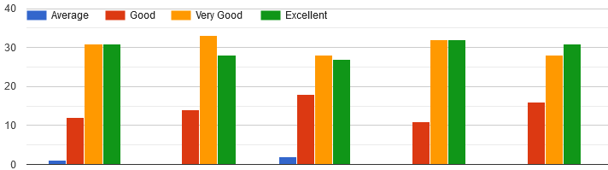

1. Regarding Command of teachers over the subject, out of **60** students, **24** students rated **Excellent & Very Good**, **11** students rated **Good** and **1** student rated **Average**.
2. Regarding Ability to teach beyond the syllabus, out of **60** students, **24** students rated **Excellent, 30** students rated **Very Good** and **6** students rated **Good.**
3. Regarding Use of ICT in teaching process, out of **60** students, **25** students rated **Excellent**, **26** students rated **Very Good**, **8** students rated **Good** and **1** students rated Average.
4. Regarding Teacher's ability to explain content knowledge, out of **60** students, **27** students rated **Excellent, 27** students rated **Very Good**, **6** students rated **Good.**
5. Regarding Integration of theory & practical in class, out of **60** students, **28** students rated **Excellent, 26** students rated **Very Good, 6** students rated **Good**.

**How do you rate the following?**

Communication skill of the teachers

Your overall experience with the college

Experience of online teaching during the lockdown period

Participation in Co-academic & Cultural Activities

The assessment & evaluation process

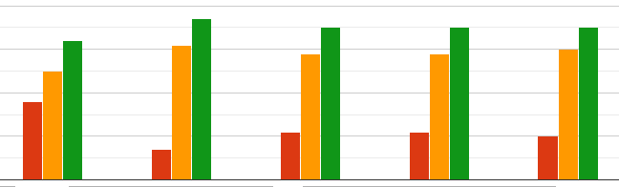

1. Regarding Communication skill of the teachers , out of **60** students, **30** students rated **Excellent ,24** students rated **Very Good**, **6** students rated **Good**
2. Regarding overall experience with the college, out of **60** students, **27** students rated **Excellent, 21** students rated **Very Good** and **12** students rated **Good.**
3. Regarding Experience of online teaching during lockdown period, out of **60** students, **29** students rated **Excellent**, **22** students rated **Very Good**, **9** students rated **Good**.
4. Regarding participation in co-academic and cultural activities, out of **60** students, **28** students rated **Excellent, 21** students rated **Very Good**, **11** students rated **Good.**
5. Regarding the assessment and evaluation process, out of **60** students, **31**students rated **Excellent, 26** students rated **Very Good, 3** students rated **Good**.

**How do you rate our infrastructure?**

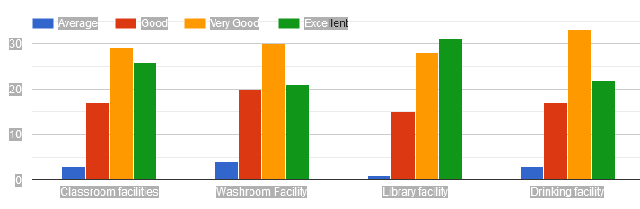

1. Regarding Classroom facilities, out of **60** students,**24** students rated **Excellent**, **26** students rated Very **Good, 7** students rated **Good** and **3** students rated **Average**
2. Regarding Washroom Facility, out of **60** students,**21** students rated **Excellent**, **30** students rated Very **Good, 20** students rated **Good** and **4** students rated **Average**
3. Regarding Library facility out of **60** students,**27** students rated **Excellent**, **23** students rated Very **Good, 9** students rated **Good** and **1** students rated **Average**
4. Regarding Drinking facility, out of 60 students,**20** students rated **Excellent**, **32** students rated Very **Good, 6** students rated **Good** and **2** students rated **Average**

**Help received from administrative staff during the course time**

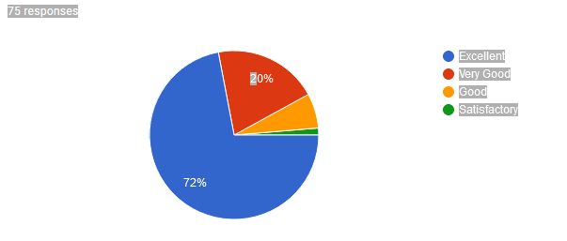

Regarding help received from the administrative staff during the course time, out of **60** students**, 72% (43 Students)** said **Excellent, 20% (12 students)** said **Very Good, 6.7% (3 students)** said **Good** and **1.3% (2 Students)** said **Satisfactory.**

**Your experience with placement cell of the college:**

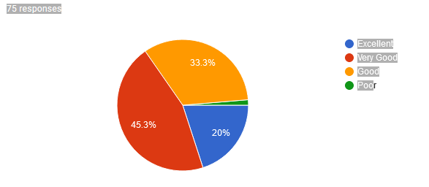

Regarding Your experience with placement cell of the college, out of **60** students**, 20% (12 Students)** said **Excellent, 45.3% (27 students)** said **Very Good, 33.3% (19 students)** said **Good** and **1.3% (2 Students)** said **Poor.**

**Support received from the colleges during Lockdown period:**

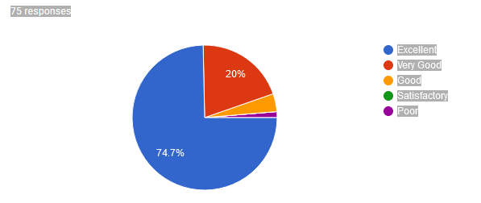

Regarding Support received from the colleges during Lockdown period, out of **60** students**, 74.70% (45 Students)** said **Excellent,20% (12 students)** said **Very Good, 4% (2 students)** said **Good** and **1.3% (1 Student)** said **Poor.**

**How do you rate assistance received from the college during the online examination?**

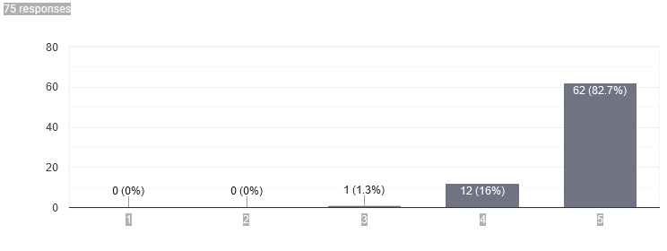

Regarding Assistance received from the college during the online examination, out of **75** students, **82.70% (50 students)** rated **5**, **16% (9 students)** rated **4** and **1.30% (1 student)** rated **3**.